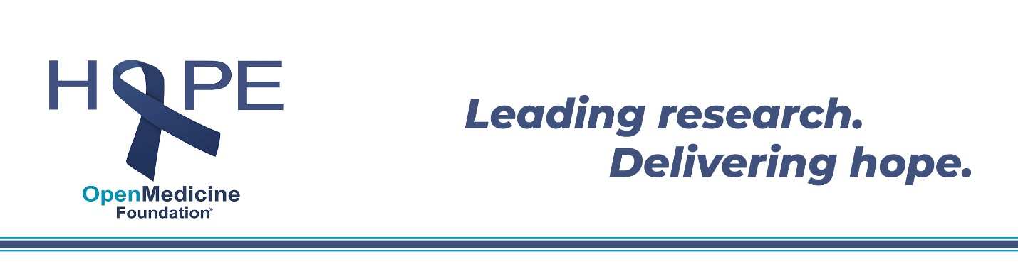Dear ____,
We’re on a mission and we need your help!
(Insert personal story about ME/CFS)
About ME/CFS:
ME/CFS (Myalgic Encephalomyelitis/Chronic Fatigue Syndrome) is a devastating, life-altering, multi-system disease affecting up to 2.5 million Americans (or 20 million people worldwide). While its impact is widespread and devastating, relatively little is known about the disease, no FDA approved treatments exist, and patients are left to deal with the illness with little help from the medical establishment, in many cases for decades. In the most severe cases, patients are left bedridden, unable to speak or eat, extremely sensitive to outside stimuli, and totally dependent on the full-time care of others.
Unfortunately, the disease still receives very little federal funding relative to its impact, instead needing to depend on private funding. Fortunately, there is now a committed community of scientists, doctors, and patients raising awareness and making great strides in finding treatments that bring ME/CFS patients some relief and hope for a normal life in the future. Open Medicine Foundation is leading research and making real headway.
Open Medicine Foundation is led by an impressive Scientific Advisory Board that includes three Nobel Prize Laureates and six National Academy of Science members and other world-renowned scientists. They have a collaborative team of more than 50 researchers working together to find answers. OMF funds the ME/CFS Collaborative Research Centers at Stanford University and Harvard University, Working Group meetings, and other critical research around the world.
Our goal is to spread awareness of ME/CFS and raise $XX,000 to support the Open Medicine Foundation. Contributions will fund research to uncover the underlying cause of ME/CFS and develop treatments for the disease, and ultimately find a cure, giving real hope for the first time to those who suffer with ME/CFS.
Donations are fully tax deductible and 100% of proceeds will go to OMF to fund research to better understand symptoms and causes of ME/CFS to potentially identify treatments and a cure.
Thank you in advance for your support, and your willingness to make a difference in the lives of millions of ME/CFS patients. You are sharing hope around the world!
With hope for all,

Insert Name

